**Introduction to CNC Machining, perform straight by using MicroTurn CNC Machine.**

**Apparatus:**

vernier caliper, Aluminum Rod,CNC Microturn.

**Apparatus:**

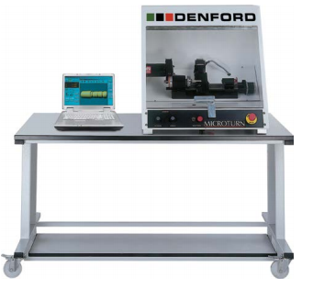

**Final Work piece Geometry**

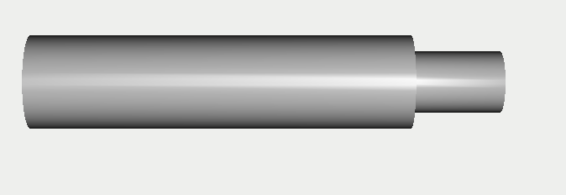

**G and M codes file**

(Quick TURN 2D Design - 12.LCM)

(10/23/2017)

(Material Type: Aluminum 2011T3)

(Tools in order of use :)

(Tool 1: Right Hand Turning Tool Tip Angle 80°)

(METRIC OUTPUT)

G21

[BILLET X20 Z100

G98

(Face Off Cut)

G28U0W0

M06T0101

G97M03S2800

G98F100

G00X20.483Z1.965

G01X20Z0

G01X-0.800

G00X0.483Z1.965

G00X20.483

G97M03S2800

(Forward Roughing Cut)

G00Z2.165

G00X19.563

G01X19.080Z0.200

G01Z-18.800

G00X21.880Z-17.400

G00Z0.200

G01X19.080

G01X17.680

G01Z-18.800

G00X20.480Z-17.400

G00Z0.200

G01X17.680

G01X16.280

G01Z-18.800

G00X19.080Z-17.400

G00Z0.200

G01X16.280

G01X14.880

G01Z-18.800

G00X17.680Z-17.400

G00Z0.200

G01X14.880

G01X13.480

G01Z-18.800

G00X16.280Z-17.400

G00X22.800

(Forward Roughing Profile Cut)

G00X20.483Z2.165

G00X-0.304

G01X-0.787Z0.200

G01X12.200

G01X13

G01X13.400

G01Z0

G01Z-0.400

G01Z-18.800

G01X19.200

G01X19.280

G01X20.080

G01X20.480

G01Z-19

G01Z-19.400

G00X20.963Z-17.435

G00X20.483

(Forward Finish Profile Cut)

G97M03S2800

G00Z1.965

G00X-0.307

G01X-0.789Z0.000

G01X12.200

G01X13.000

G01Z-0.400

G01Z-19.000

G01X19.200

G01X20.000

G01Z-19.400

G01X20.080

G00X20.483

M05

G28U0W0

M30

Differentiate between CNC and NC Machining?

__________________________________________________________________________________________________________________________________________________________________________________________________________________________________________

Differentiate between open and close loop system?

__________________________________________________________________________________________________________________________________________________________________________________________________________________________________________

Write advantages and disadvantages of CNC machining?

__________________________________________________________________________________________________________________________________________________________________________________________________________________________________________

**Assignment:**

**Submit an assignment on general CNC machining codes.**